Student Name 1:
Student Name 2:
IP Address block: 172.20.____.______

Topology Diagram
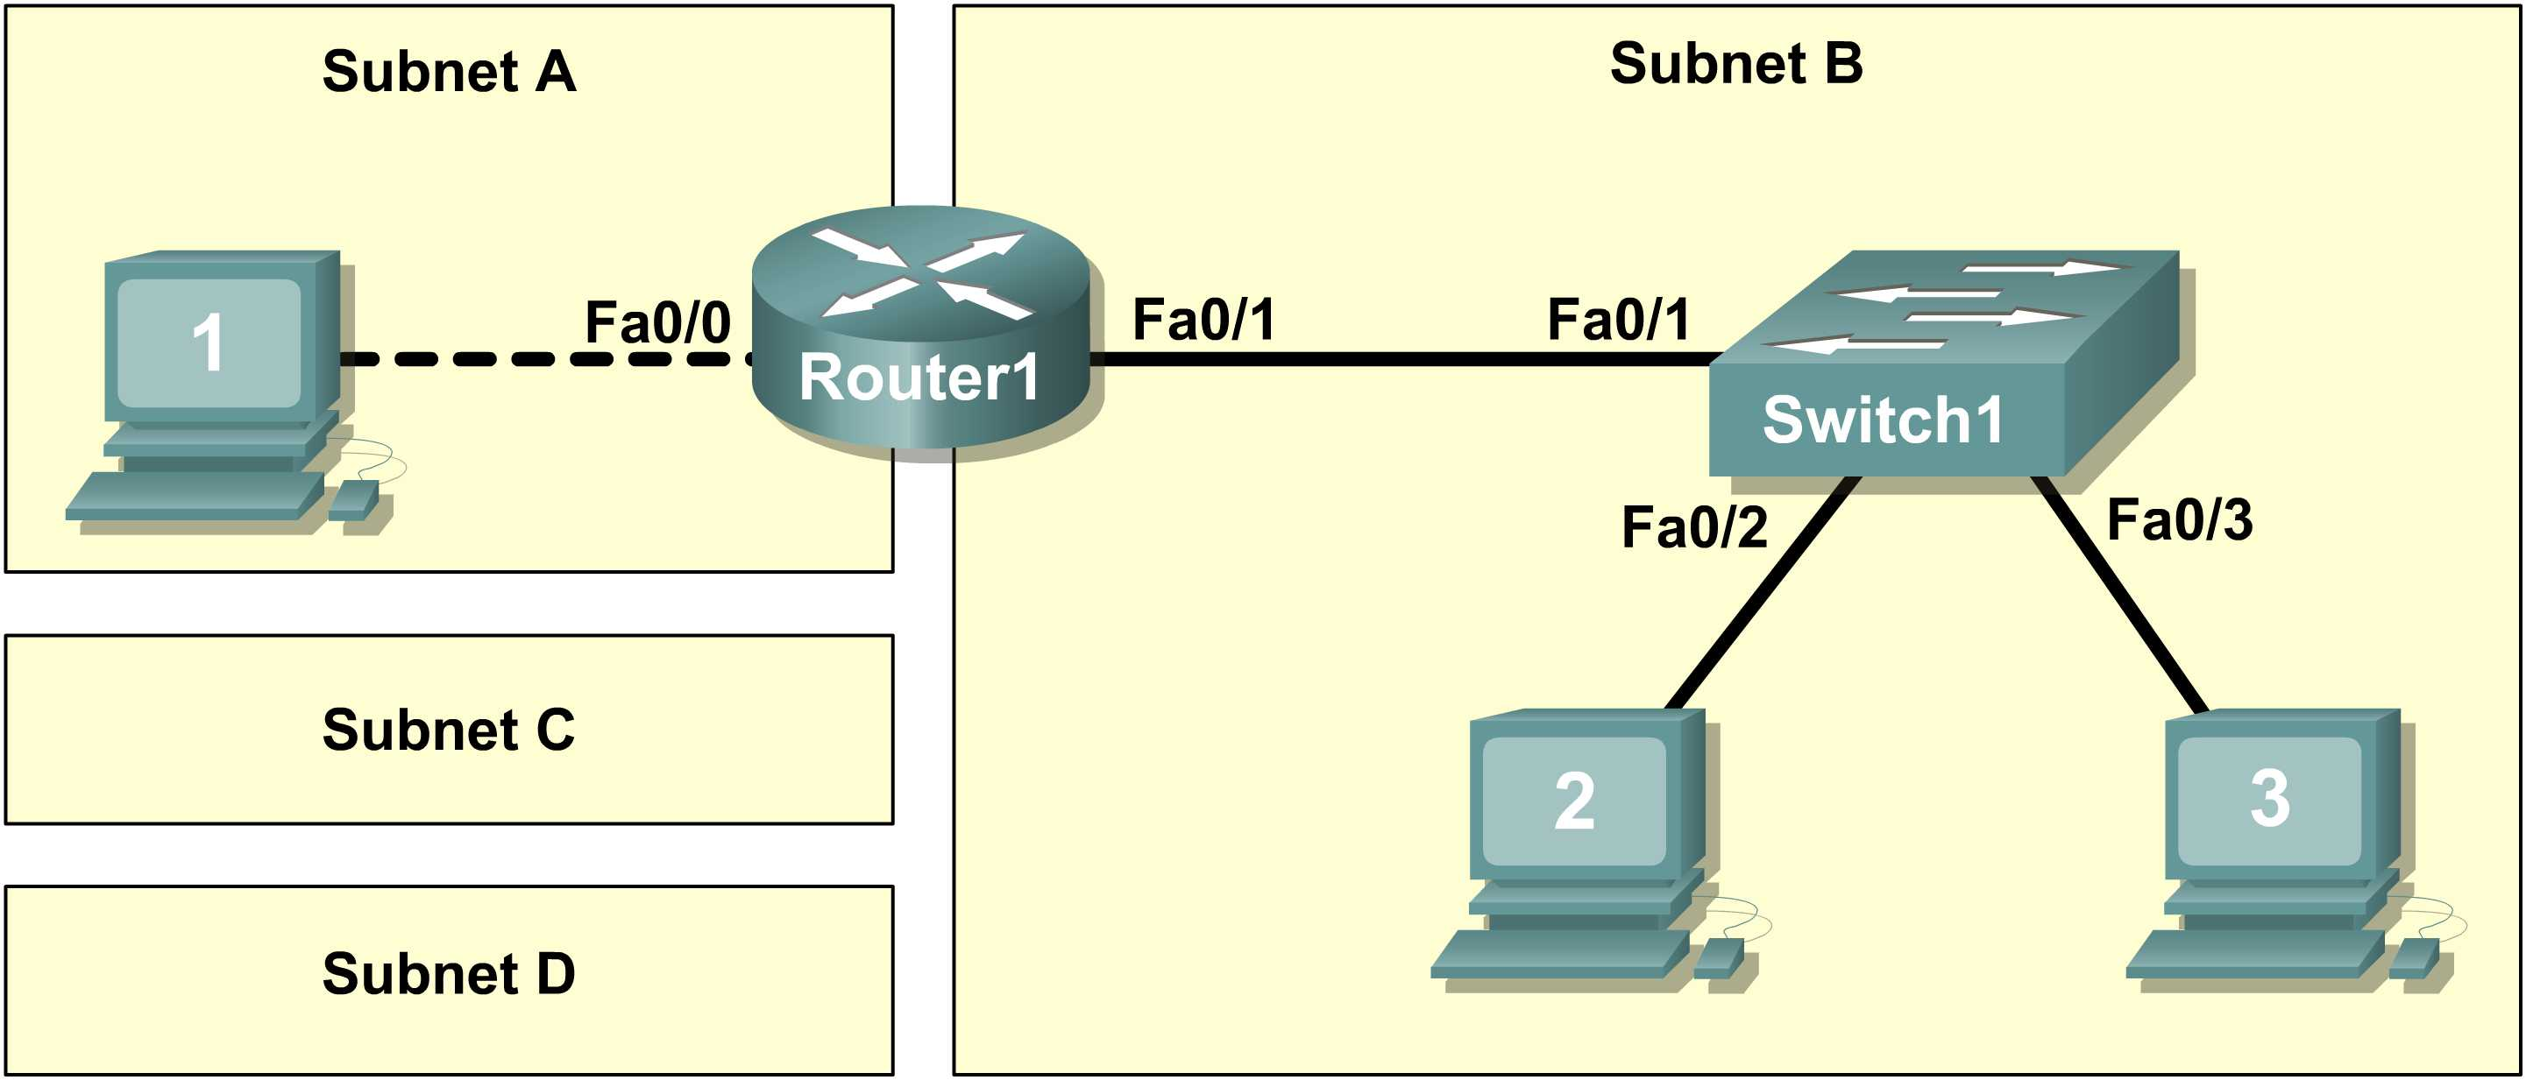
Figure 1. Cabling the Network

Task 1: Design the Logical Network.
Step 1-4: Design SubnetD address block.
Q1-Q4
Sub Network | Network Address | x.x.x.x Mask | /nn Mask | First Host Address | Last Host Address | Broadcast
D
C
B
A

Task 2: Configure the Physical Lab Topology.
Step 2: Network connections.

Q5 Host1 MAC Address : ________________________________

Q6-Q11
From | To | Cable Type
Host_1 | Router_1 Fa0/0
Router_1 Fa0/1 | Switch_1
Host2 | Switch_1
Host3 | Switch_1
Task 3: Configure the Logical Topology.
Step 1: Document logical network settings.
Q12
Host1 (use first address from subnet A)
IP Address
IP Mask
Gateway Address
Host2 (use first address from subnet B)
IP Address
IP Mask
Gateway Address
Host3 (use second address from subnet B)
IP Address
IP Mask
Gateway Address
Router1 Interface Fa0/0
IP Address
IP Mask
Router1 Interface Fa0/1
IP Address
IP Mask
Task 4: Verify Network Connectivity.
Q13 [2 marks]
From | To | Source IP | Target IP | Ping Results
Host1 | Gateway (Router1, Fa0/0)
Host1 | Router1, Fa0/1
Host1 | Host2
Host1 | Host3
Host2 | Host3
Host2 | Gateway (Router1, Fa0/1)
Host2 | Router1, Fa0/0
Host2 | Host1
Host3 | Host2
Host3 | Gateway (Router1, Fa0/1)
Host3 | Router1, Fa0/0
Host3 | Host1

Q14 In the above scenario, how can a malfunctioning Gateway be detected?
___________________________________________________________________________________
___________________________________________________________________________________
Task 6: Challenge [3 BONUS marks]
Ask your instructor to introduce one or two problems in your network , then fix them.
- Perform a good visual inspection. Look at the status of the device ports by hovering your mouse over the device icon.

Use the table provided in Task 3 to identify failed connectivity. List the problems:
_____________________________________________________________________________
_____________________________________________________________________________
_____________________________________________________________________________
_____________________________________________________________________________
_____________________________________________________________________________
Write down your proposed solution(s):
_____________________________________________________________________________
_____________________________________________________________________________
_____________________________________________________________________________
_____________________________________________________________________________
_____________________________________________________________________________
Test your solution. If the solution fixed the problem, document the solution. If the solution did not fix the problem, continue troubleshooting.
_____________________________________________________________________________
_____________________________________________________________________________
_____________________________________________________________________________
_____________________________________________________________________________

Note: At this point you should call your lab instructor to have your lab check in.

To be filled in by Lab Instructor

☺ IP subnetting ☺ Connectivity
☺ Cabling ☺ Problem / Fix

Lab Instructor _______________________

